Head Lights of The Car Opens on Dark & build structure of Car (motors with RPI)

My project for this lab it to build a light sensor that turn the Head Light of the car when dark. The idea is to build the sensor using Propeller Activity Board that sense the environment that its driving in. When the Ligh-Sensor sense that the environment is dark, it will turn on a light on the board indicating that the environment is dark.

**Section 1. lab 6 will be on the Propeller board only. I will build the sensor using**

* Phototransistor
* capacitor
* resistor
* LED Light

**Logic Circuit :** As you can see, when light sensor sense light is dark, it lights up LED.

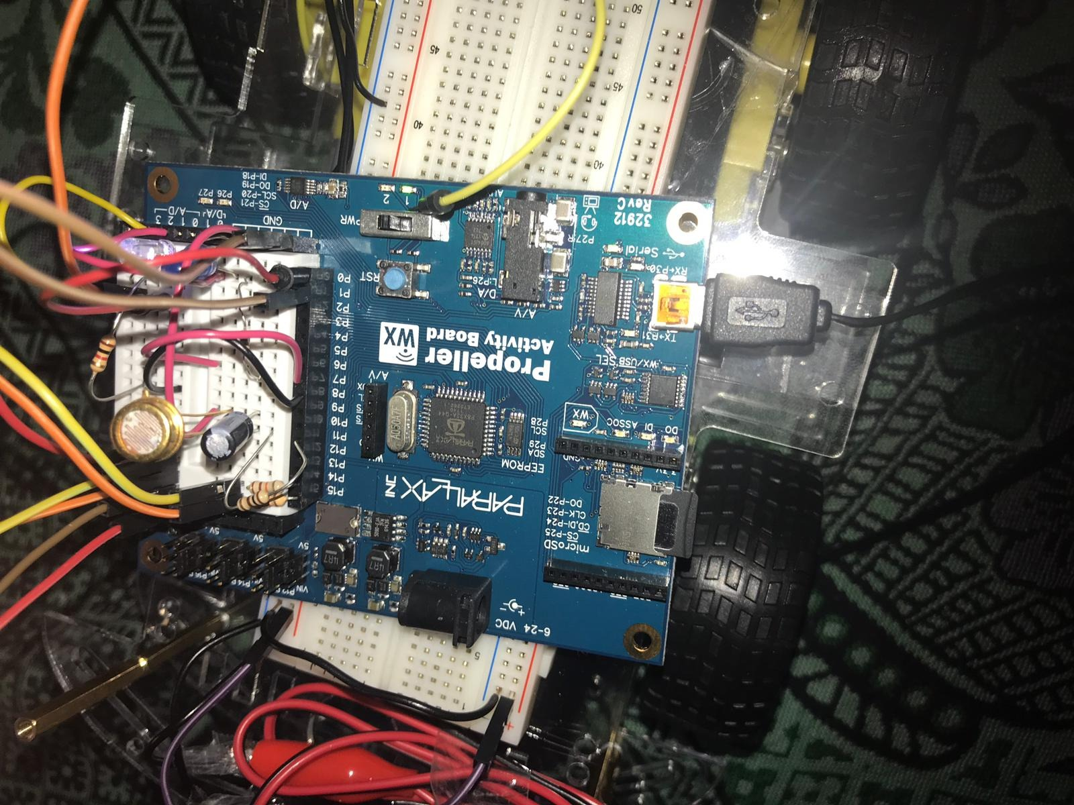

**CODE:**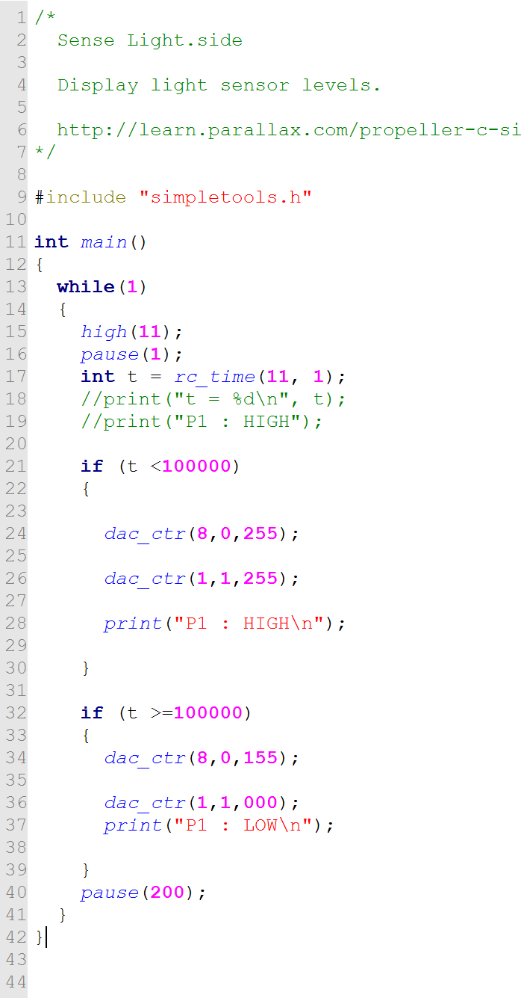

**Test – When No Dark – LED OFF :** We can see that when the sensor sense that there is enough light, there is no reason to turn on the LED. Hence, headlights.

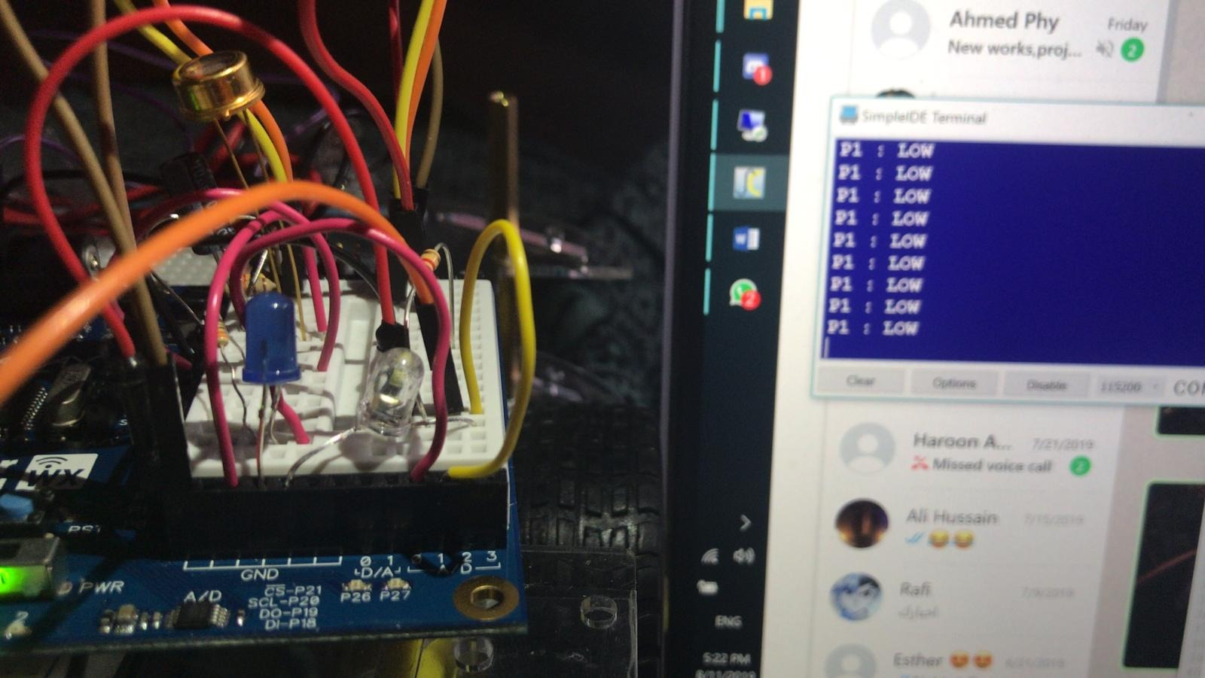

**Test – When Dark – LED ON :** We can see that when the sensor sense that there is NO enough light, the LED WLL TURN ON. Hence, headlights.

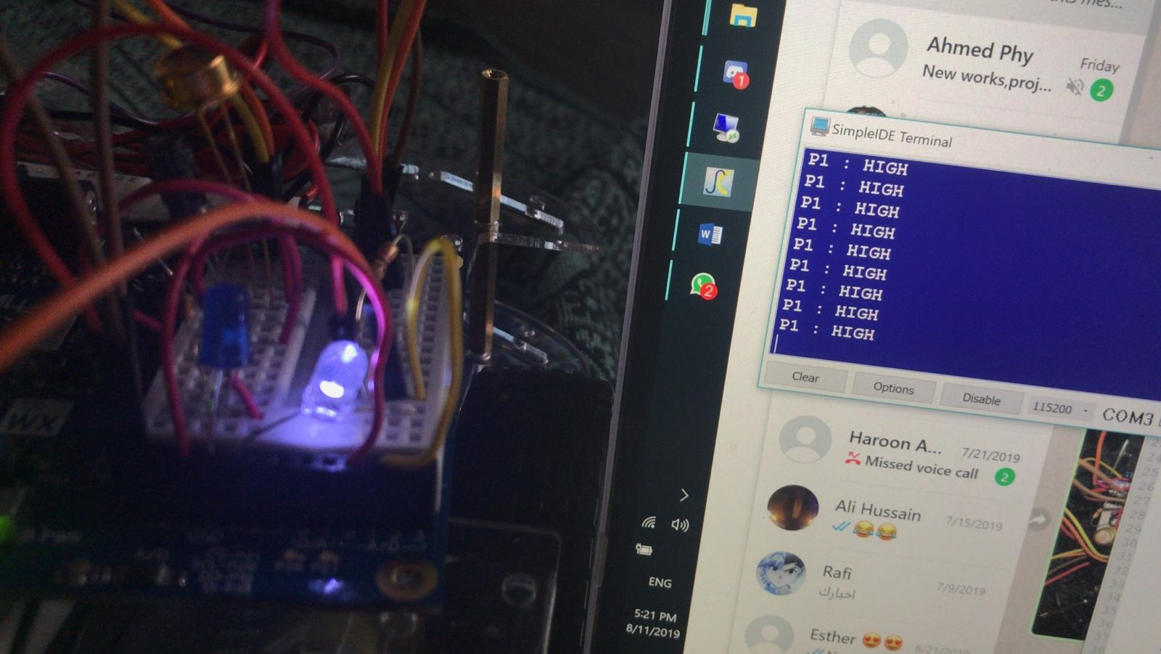

The purpose of this lab is to build a working automatic Light-Sensor system that will communicate with the RPI to let it know when to open lights and when to close it.

So, the secondary microcontroller, in this case is Propeller, will determine when to send signal as HIGH or LOW to RPI, and RPI will handle the lights OFF or ON. This will be LAB 7.

**Section 2. Build Structure of the Car with RPI and L289 Bridge and 4 motors**

In this section I will build a code using Python and RPI to control 4 motors. The idea is to design a system that runs the car foreword, backwards, turn left, turn right, speed 1, speed 2, speed 3.

* **Building the 4 motors and connecting it to the motor controller**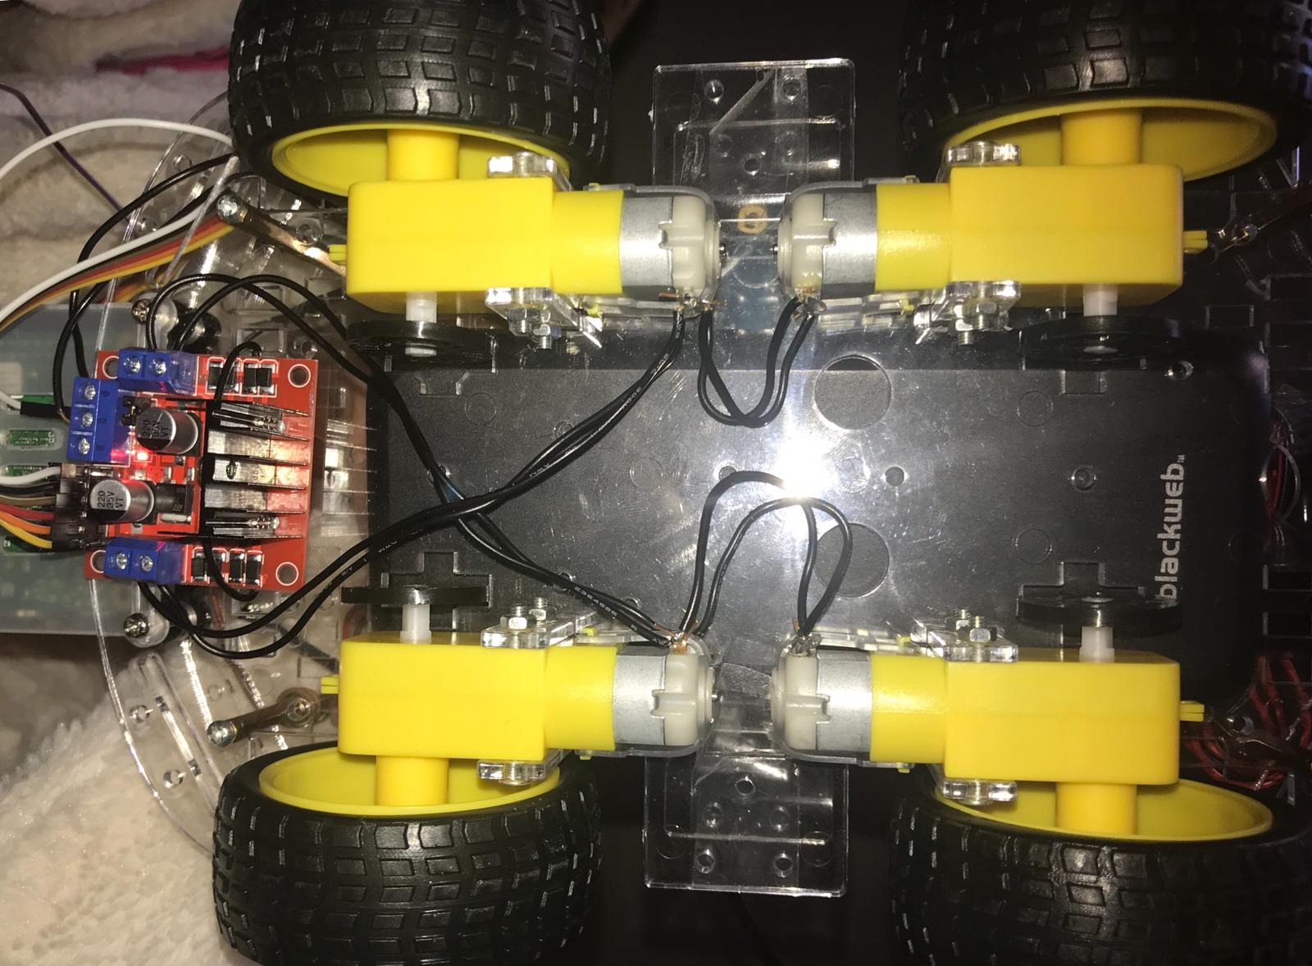
  + As we can see in the above picutre, each two motors are connected in reverse with each other and and connected to one side of the Motor Contorller (+, -). And same with the other side.
  + 6 pins coming our from it to the RPI GPIO pins as output to controller the motors.
  + 1 pin as 5v and 2 ground.
* **RPI Circuit :** The arrow is to show the pins coming from Motor controller to the RPI.

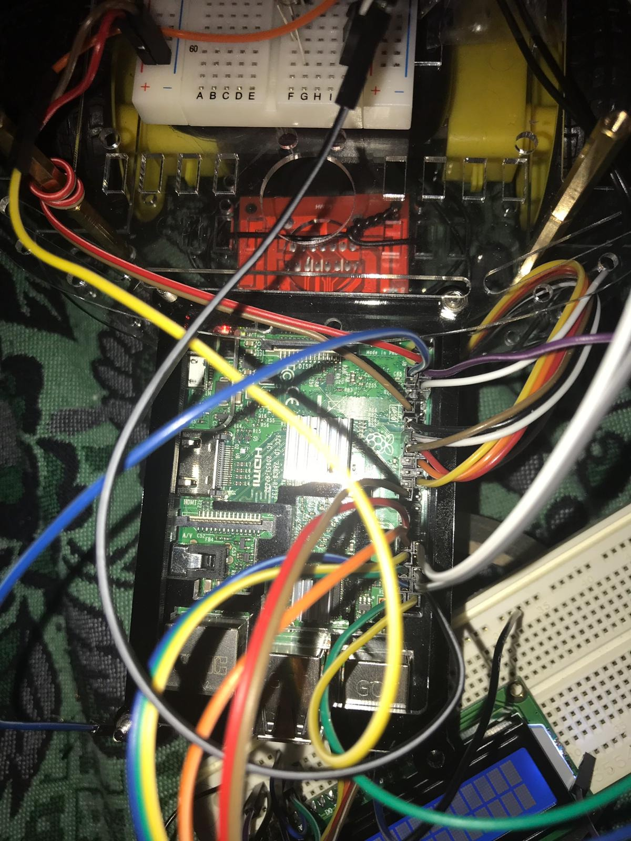

**CODE to start and move the car**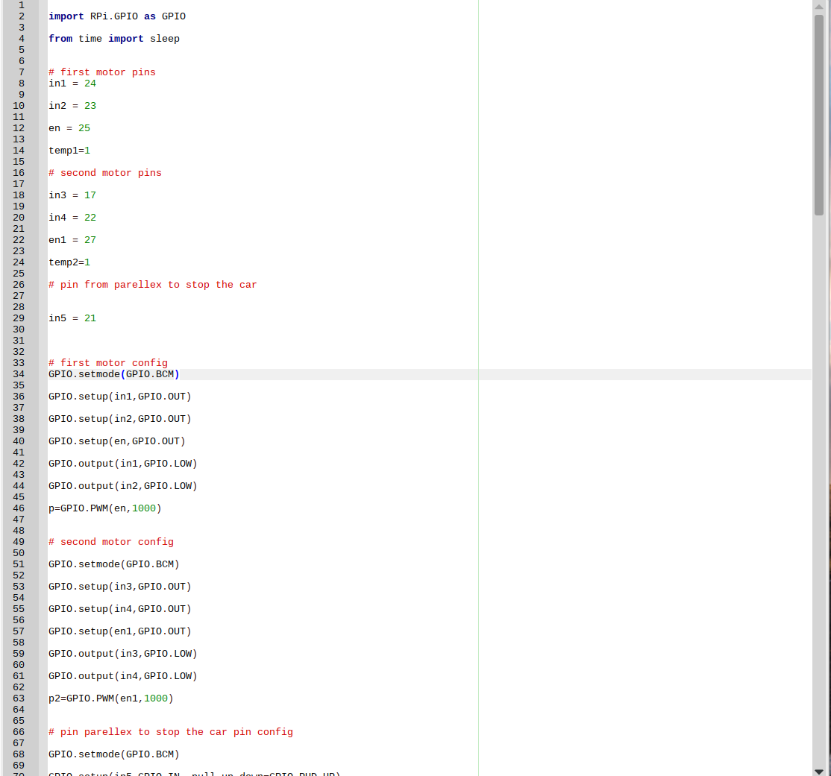

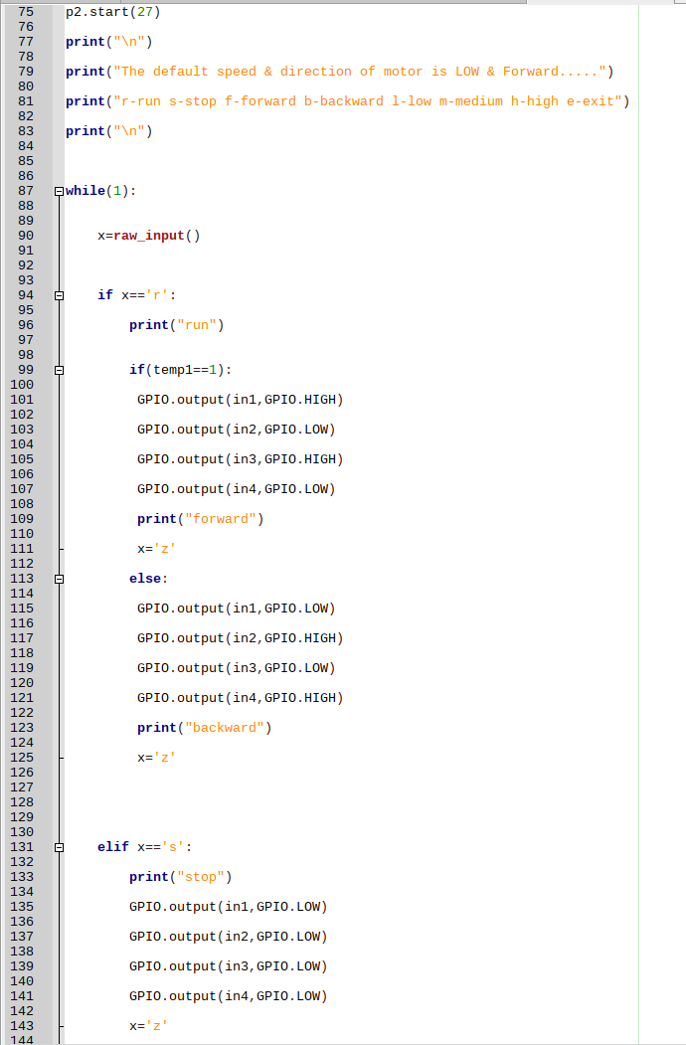

**Test Code & Circuit.**

